Chapter 1
Introduction and Motivation

  - Background of Industry

Reliance Industries Limited (RIL) is an Indian multinational conglomerate company founded by Shri Dhirubhai Ambani and currently headed by Shri. Mukesh Ambani, headquartered in Mumbai, India. Reliance owns businesses across India engaged in energy, petrochemicals, textiles, natural resources, retail, and telecommunications. Petrochemicals, one of the pet business of RIL, also referred to as PetChem, is the largest producer of petrochemicals in the country, and amongst the top ten in the world. It produces a variety of PET Products such as Polymers, Polyesters, Elastomers, Fibers, etc. The department collects lot of data generated by the business, and to maintain that data, has set up an IT Division where different teams create internal organizational software as per requirement and perform maintenance and upgradation of old software.

  - Motivation

The main motivation for the internship is to ensure smooth transition from the academia to the industry after graduation. Students often struggle to adjust to the new corporate environment after they come out of their engineering course. Many students are not able to intern in industries, due to the heavy workload of the engineering curriculum, and even if they are able to intern, it is only for a couple of months which is not enough to build momentum and prepare the engineer’s mind for the industry. Thus Semester Long Internship provides that momentum that allows me to enter the industry with confidence, and even if the technology stack or domain of the software changes, it rarely matters, since the software engineering process remains the same, and the important business and soft skills are used everywhere regardless the nature of work.

Some of the reason why students struggle during transition from academia to industry:

- In the final year/semester of the students, the project is simply a part of the engineering curriculum, which means that students have to study other subjects along with the project, which includes assignments and term tests for the subjects. Due to this, the effort gets divided between theory subjects and the project, and thus students are not mentally prepared to work on a single project for whole workday attending meetings alongside. Thus industries give training to the freshly joined employees to make them accustomed to this. However, Semester long Internship Removes this barrier, by relieving us from attending lectures and various continuous assessment components that are required for theory subjects and allows the students to directly attend the end semester examination(ESE).

- In engineering final year projects, students, who are doing software projects, do not apply latest industry software engineering practices such as agile or scrum models. One of the reasons maybe due to that the problem at hand is not complex and large enough to apply these models and thus students apply simple models such as incremental model, waterfall model, etc. However, in industries, business problems are complex and also need to be scalable in the future. Keeping these things in mind, agile or scrum or similar practices are applied. Since the student is acquainted about this practices only theoretically, he or she is not able to adapt to the practices used in the industry and thus needs training in order to adapt to the process. Semester Long Internship allows us to involve in these practices through internship in the industry and thus makes us more capable than other students in this area.

Other personal motivations include:
- Interviews for full time jobs are much more rigorous as there is much stake for the organization, thus it becomes hard to get selected in the companies, given how there is rampant growth of unemployed engineers in the country. Interviews for internships are much simpler and it is relatively easy to secure an internship. From the perspective of the industry it makes more sense to recruit after seeing the performance of the intern, since it is inexpensive to keep the intern and easily judge whether the student is fit as an employee for the organization.

Similarly, from the perspective of the student, it makes much more sense to easily get an internship and later get absorbed as a full time employee, than attending job interviews hither and tither, and having low chances of getting a job

Due to above reasons, semester long internship would benefit to my career and thus this makes it worth applying for.

  - Scope of the Internship

The nature of the internship is that of a full stack developer. The responsibilities include:

- Learn the technology stack (Angular, Java Spring Boot, MySQL Workbench) while the project is in the design phase, and this learning continues even after core concepts are learnt, while applying the skills for completing tasks/deliverables.

- Attend project progress meetings and suggest solutions for solving sub-problems of the project.

- Finish the tasks/deliverables for the frontend / backend of the project assigned by the industry mentor and give regular updates of the progress. Furthermore, optimize the solution so that it becomes scalable.

- Test the deliverables of other team members and report bugs to the mentor. Fixing the bug if possible (which becomes another deliverable). Testing includes but not limited to acceptance testing, negative testing, validation testing, white-box testing and black-box testing.

- Perform Documentation of the software.

  - Brief Description of the work undertaken

I am a part of one of the Teams at Petchem IT division working at a project titled “Petchem Business Data Management”. As an intern, I have to collaborate with other team members, who are full time employees, for the development of the project. The project stack includes the following components:

- Angular Framework for Frontend
- Java Springboot for Business Logic
- MySQL Workbench for data storage

Brief details of the nature of the tasks given to me as follows:

- Write routines in angular typescript and java springboot, which implements certain functionality of the component. Test if written code works and after mentor approval, push the code to Azure DevOps Repository.

- Test a particular page and trace the bug. The component maybe developed by a different team member. If possible locate the typescript or Java code routine that is causing the bug and fix it, and push the updated code to the repository.

- Preparing Standard operating procedure and other documentation including but not limited to such as documenting test cases for pages that are tested for future reference, presentation slides, etc.

Chapter 2
Concept of the Internship

2.1 Internship Objectives
The objectives of the internship are the following:

- To learn different technologies related to full stack development and update my skillset.
- To learn agile methodology and apply it practically in real time
- To learn how to communicate and collaborate with the team
- To prepare the mind to work 8 hours a day, without being exhausted, and become more confident to take up challenging tasks.

2.2 Internship Methodology

At Reliance Industries Limited, they perform the following to ensure maximum learning for the intern:

- Onboard the intern, and make the intern acquainted with the environment. A project for the intern is identified, only those which are at a planning and analysis phase, so that the student learns all the phases of software development life cycle (SDLC).

- While the problem statement is still being discussed, the intern has to attend the meetings and give his or her valuable suggestions for the improvement of the project design. During this phase the intern is given some material to learn the technology. For 1 – 1.5 months the intern learns the technology and is given some learning project to do, so that it reinforces learning by doing. During this period, a mentor from the team is assigned who will guide the intern properly.

- After the learning project is over, the intern can return back to the main project, joining the ongoing sprints. At this phase the intern is assigned deliverables by the mentor (development, testing, documentation tasks), and the progress of the deliverable is regularly reported to the mentor.
Chapter 3
Flow diagram / Methodology

  - Introduction

Reliance Industries Limited collects and maintains a lot of data for its PetChem Business. This data is utilized in various ways:

- Make quarterly / yearly reports of the data
- Maintain records for Audit
- Use data for Business Intelligence purposes: Such as data analysis, visualization, prediction, etc.
And many other ways.

Currently the organization is facing a few challenges regarding the data:

- Data is continuously flowing on a daily basis. The data is primarily captured in the form of excel sheets.

- This data has to be mapped in tableau dashboards for business intelligence.

- Data is dynamic, i.e. the fields (attributes of data) change from time to time, and have to be updated.

- Ownership of data lies only with the business owner as per the organizational norms and rules. Thus updating the master table is an overhead.

- The BI Team cannot use any data for their visualizations/ analytics purposes unless approved by the respective authorities.

- There is no system which after having owner approval automates the process of data structure updation, in a fast and seamless manner, thus optimizing the overall process.

  - Problem Statement

The system named “Petchem Business Data Management”, suggested by the Petchem IT Team, solves the above problem, by allowing the user to submit use cases (which are essentially the data description), to the business owner, and after approval, the user can upload data, which gets updated in the database.

Users of the System:
- Normal User: RIL Employee working in data / BI / Any other group of Petchem Department
- L1 User: Immediate Reporting Managers of employee user
- IT Admin: IT Head for particular division.
- Business Data Owner: Head in charge for that particular business is the Business Data Owner.

    - Objectives
Following are the objectives of the system:

- Allow a user to submit use cases to the system
- User can decide who can read the data, edit the data, etc. By Default, the business owner is read only user of the use case
- User can specify the data attributes, and their types (text, long text, number, decimal, date)
- User is able to submit the use case, or save the request as a draft to come back later to edit the request.

- Following is Decided to be the approval chain of the system:
Use case Submitted => L1 Approval => IT Admin Approval => Business Data Owner Approval

- Users will be able to track the use case status. The approvers will know the use cases that are pending under them. They can approve the use case, reject or send it back to the user for further changes.

- After the approval, the user can now upload data to the use case, through excel sheet. The excel sheet needs to be validated and then gets uploaded.

- The user should able to search data in the use case and able to download required data in the form of excel sheet.

- Every activity is to be logged for audit purposes.

  - Project Requirements
    - Hardware Requirements

- The software is going to be deployed on the intranet, on Linux Servers available with the organizations.

- To access the system, the user needs to have a windows desktop and connected to RIL eVPN Service or to a Citrix System and navigate to the appropriate URL once it is hosted.

    - Software Requirements

The system is a web application with the software stack adhering to standards of the organization:

- Frontend Framework: Angular 9
- Business Logic: Java Spring Boot (with embedded tomcat)
- Database: MySQL
- Tools / Editors / IDEs Used: VSCode, Spring Tool Suite (STS), GIT CLI

Organization has Azure DevOps system, where code can be pushed to repositories, and is also used to assign deliverables, keep track of deliverables, and other SDLC Functions.

  - Project Design
    - System Architecture:

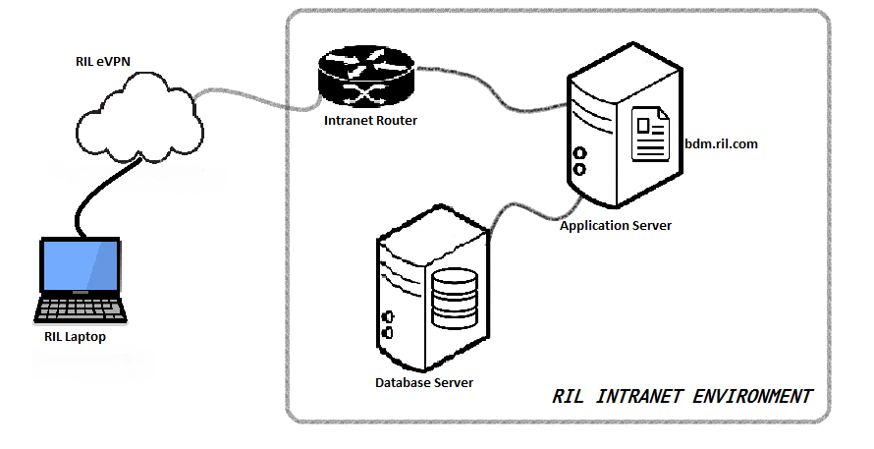
Fig 3.1 System Architecture

3.4.2 System Modules
The system has following modules:
- Login: User SSO Login through LDAP Credentials

- Landing Page: A Dashboard Where users can see pending usecases, add new usecases, see approved usecases where data can be uploaded.

- Add New Usecase: For adding new usecases.

- Use case approval: For reviewing requests and approving/rejecting them

- Approval List: Check status of submitted usecases.

- Use Case: For viewing data in the use case, searching it, downloading data, uploading new data, etc.
3.4.3 Use Case Diagram
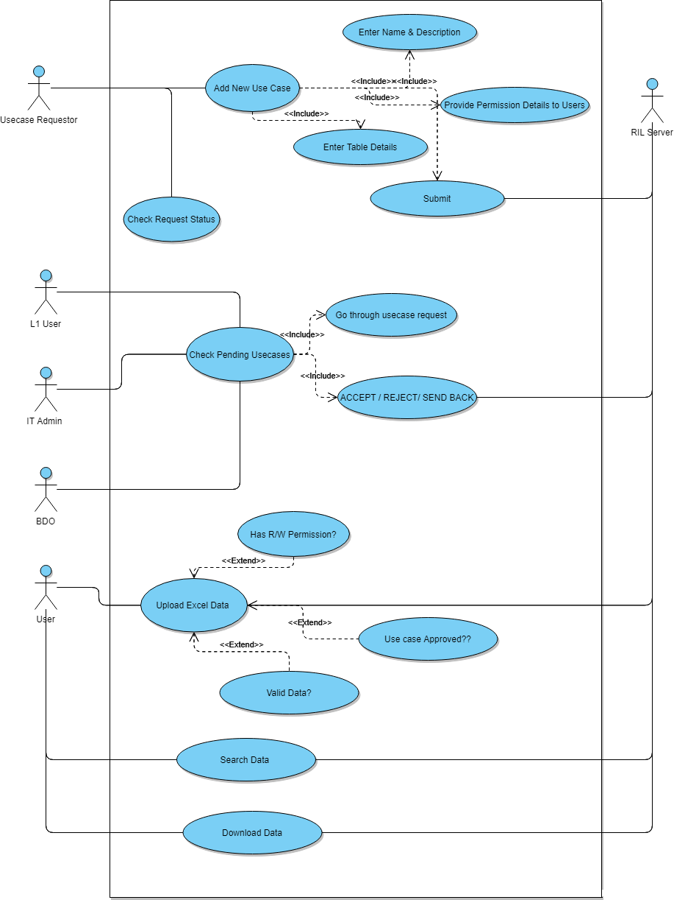
Fig 3.2 Usecase Diagram

3.4.4 Flowchart/Workflow of System
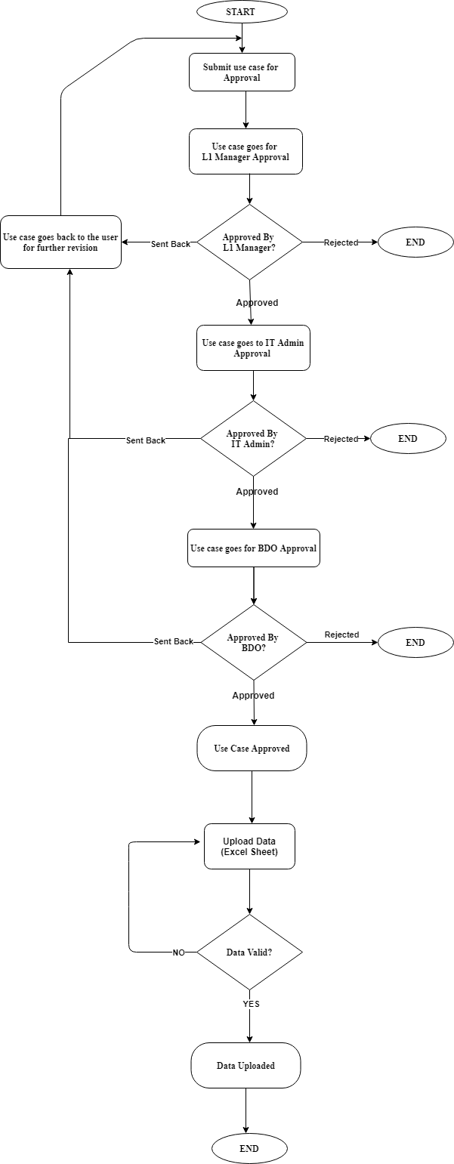
Fig 3.3 Flowchart
Chapter 4
Implementation and experimentation

4.1 Software Development Lifecycle Model
Agile Model
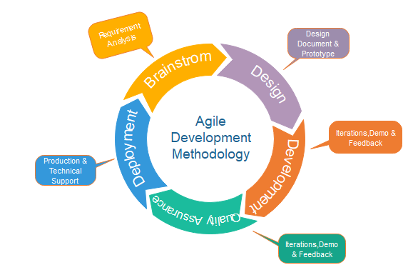
Fig 4.1 Agile Model
The IT Team of Petchem Department of RIL uses Agile modeling for its software development lifecycle.
- The project got initiated in the first week of January 2021. Meetings were conducted for brainstorming ideas and gathering requirements information from other teams.

- Once the requirements were finalized, the design of project took place. Since the software and hardware technology were fixed, focus went on designing the workflow of the system, and deciding the modules and the users of the system.

- Wireframes were designed for every page of the system and these were sent to a separate UI Design Team for creating templates.

- Once the UI was finalized the development (Sprint 1) began in mid-February.
Each sprint here lasts for about 2 working weeks.
- During these time deliverables were assigned to me.
- At the time of making this report, the development is at Sprint 3 Phase.

4.2 Internship Timeline
Following is the timeline of my internship along with gantt chart.
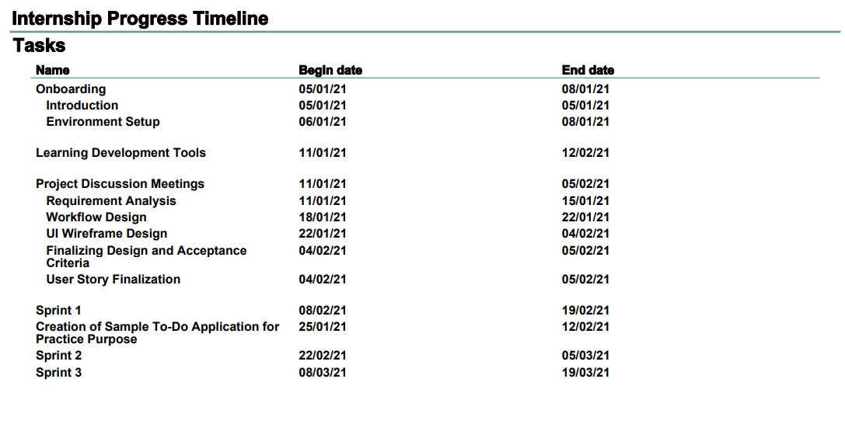

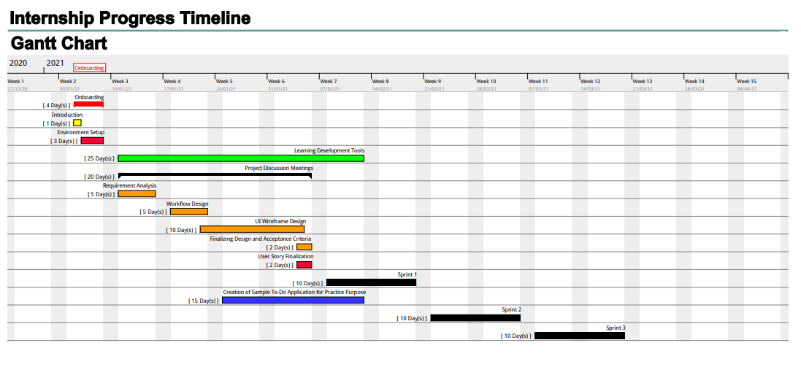

4.3 Deliverables
Following is rough list of deliverables I undertook in the internship

SR. No | Deliverable
01 | Sub-module functionality: To allow user to add permissions to other users while creating use case ( in add new use case)
02 | Bug Fix: Fix checkbox issue in add new use case and use case page.
03 | Testing: Perform User Acceptance Testing on add new use case page
04 | UI Changes / Add-ons : Make some items toggle-able so that they do not cover the page when not needed
05 | Testing: Perform negative testing of add new use case page
06 | Testing: Perform Acceptance testing of use case approval at all levels (Submit use case => Approve L1 => Approve IT Admin => Approve BDO)
07 | Sub-module functionality: populate drop down to show use cases on dashboard page.
08 | Bug Fix: Fix SSO Feature of login.
09 | Fix CSS : In some pages the responsive tags were not working, identify and fix proper css attributes to fix some of the items in add use case page
10 | Write Standard Operating Procedure for the whole system

Chapter 5
Key learnings from the Internship

5.1 Technical Learnings
The following is the list of things I learnt that add to my technical skill set

- Sharpened my web development skills: Although I had learnt angular in my engineering course, it was very brief and did not make the framework ingrained in me. However, working daily has sharpened my skill set in the web domain especially in css and angular framework.

- Learnt a new framework: Spring Boot: This Internship allowed me to learn a new Java Framework called spring boot which is a standard for enterprise application as it is very secure, and easy to maintain. The concept of micro services was introduced to me where we can create services that serve different modules of our project instead of adding redundancy of code in the modules.

- Introduced me to Functional Programming: Refers to my habitual coding practices in my engineering assignments, where I used to code every logic from scratch. However, I was guided by my mentor to learn functional programming, by looking up documentations of the frameworks we were using, because:
- It helps to save time
- Makes code more readable
- Uses more optimized routines than the one we create when we code from scratch

- Version Control Tools: In the courses I was taught how to use GIT, however in reality I never used it for any of my projects. In the internship I had to revise and refresh my knowledge of GIT Client so that I could resolve code conflicts. Thus I have more confidence while using version control tools.

- Taught me the Importance of writing Optimized and Secure code:
In engineering we were taught about optimization of algorithms. However, it was still fine if we could write slightly sub-optimal code and as long as we got output quickly, it would be fine. However, while writing code for enterprise applications, not writing optimized code will make your application slow, although it may appear fast while testing on short amounts of dummy data, the sub-optimality of the code will show its effects on real large amounts of data. Since the application is always made to be scalable in the future, all code has to be as optimized as possible.

Secure code is also very important as privacy of enterprise data is of paramount importance. My mentor mentioned that at RIL, they have a QA Team which will run automated tools on the application code and reject application if vulnerabilities are found.

5.2 Non – Technical Learning

Chapter 6
Results and Conclusions

Chapter subtopics should be font 14 Times New Roman and 1.5 spacing bold, left aligned and justified
6.1 Results
6.2 Conclusions

